|  |
| --- |
| IFMR RURAL FINANCE |
| SCREENING |
|  |
| **IFMR Rural Finance** |
| **10/25/2016** |

|  |
| --- |
|  |

Contents

1. Process Diagram 3

2. Stage definition 4

3. Stage-role access 4

4. Screening Queue 4

4.1 UI specification 4

4.2 Screenshot 5

4.3 Functional requirements 6

4.4 Upload 6

4.5 Download 6

4.6 Reports 6

5. Capturing Screening data 7

5.1 UI requirements 7

5.2 Screenshots 34

5.3 Functional requirements 59

5.4 Uploads 59

5.5 Downloads 59

5.6 Reports 59

6. Screening Score 60

6.1 UI specification 60

6.2 Screenshot 60

6.3 Functional requirements 60

6.4 Upload 63

6.5 Download 63

6.6 Reports 63

# Process Diagram



# Stage definition

|  |  |
| --- | --- |
| **Stage** | **Description** |
| Screening Queue | The Loan Officer Selects a profile from the Screening Queue |
| Capture Details | The loan Officer captures data and sends the same for auto approval. |

# Stage-role access

|  |  |
| --- | --- |
| **Stage** | **Applicable Role** |
| Screening Queue | Loan Officer |
| Capture Screening Details | Loan officer |

# Screening Queue

## UI specification

|  |  |  |  |  |
| --- | --- | --- | --- | --- |
| **Field name** | **Section** | **Data Type** | **Attribute** | **Population logic** |
| S. No. | Screening Queue | Numeric |  |  |
| Screening Date | Screening Queue | date | Sort/Search | From Lead Generation Stage |
| Applicant Name | Screening Queue | Text | Sort/search | From ‘Lead name’ of lead generation stage |
| Business Name | Screening Queue | Alphanumeric | Sort/search | From Lead Generation Stage |
| URN No | Screening Queue | Alphanumeric | Sort/search | From System database |
| Area | Screening Queue | Text | Sort/search | From Lead Generation Stage |
| City/Village/Town | Screening Queue | Text | Sort/search | From Lead Generation Stage |
| Pincode | Screening Queue | Numeric |  | From Lead Generation Stage |

## Screenshot

1. Search Page

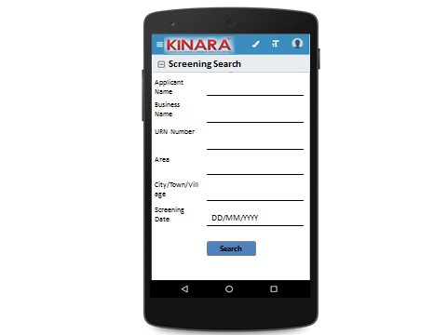

1. Screening Queue



## Functional requirements

* **Loan Officer** logs in
* The loan officer opens the process dash board, and enters the Screening queue.
* If the loan officer performs a search without selecting any parameter, then all cases with status ‘Pending for Screening’ to be displayed in a tabular format
* Also display all the cases which have been assigned to loan officer from existing customer.
* If the loan officer searches with ‘Applicant name’, ‘Business name’ or ‘URN no’, then all matching records (including existing customers) to be displayed in a tabular format
* The loan officer can **search and sort** the profiles based on the following parameters: Screening date, URN no, Applicant Name, Business Name, Area, City/Village/Town.
* The loan officer then selects a profile from the Screening queue. The queue table should have applicant name, business name, URN No, Area, City/Town/Village and Screening Date as column names.
* All the columns will have **sorting** facility.

## Upload

-NA-

## Download

-NA-

## Reports

Lead Management Funnel - No. of leads generated, no. approved, no. non rejected and no. disbursed

# Capturing Screening data

## UI requirements

|  |  |  |  |  |  |  |  |
| --- | --- | --- | --- | --- | --- | --- | --- |
| **Entity** | **Tab** | **Sub tab** | **Fields** | **Field Value** | **Mandatory** | **Conditional Mandatory** | **Remarks** |
| APPLICANT | Applicant Profile | KYC Details | Aadhar No | Numeric | Yes |  | Aadhar -QR Code Scan (Auto fill Profile & Address data) |
| Document Capture | Upload | Yes |  |  |
| Pan Number | Alpha numeric | Yes |  |  |
| Document Capture | Upload | Yes |  |  |
| ID Type | Dropdown |  |  | Ration Card, Voter Card, Passport, Pan Card, Aadhar card, Driving License |
| ID No | Alpha numeric |  | Yes | If ID type selected |
| Valid up to | Date |  | Yes | If ID type selected |
| Document Capture | Upload | Yes | Yes | If ID type selected |
| **Add Button** |  |  |  | ID type, ID No, Valid Up to, Document Capture populate again |
| Applicant Details | Title* | Auto populated/  Text | Yes |  | Aadhar QR Code scanning |
| Name* | Auto populated/ Text | Yes |  | Aadhar QR Code scanning |
| Gender* | Auto populated/ Text | Yes |  | Aadhar QR Code scanning |
| Date Of birth* | Auto populated/ Date | Yes |  | Aadhar QR Code scanning |
| Age | Auto populated |  |  |  |
| Father's Name* | Auto populated/Text | yes |  | Aadhar QR Code scanning |
| Educational Level* | Dropdown | Yes |  | Below SSLC, SSLC, HSC, Graduate/Diploma/ITI, Professional Degree, Others |
| Religion* | Dropdown | Yes |  | Hindu, Muslim, Christian, Jain, Buddhist, Others |
| Mobile No* | Numeric | Yes |  | from lead |
| Alternative Mobile No. | Numeric |  |  |  |
| WhatsApp Mobile No. | Numeric |  |  |  |
| Email ID | Alphanumeric, special characters |  |  |  |
| Preferred language of communication* | Dropdown | Yes |  | Hindi, English, Kannada, Malayalam, Gujarati, Marathi, Tamil, Bengali, Odia, Punjabi, Marwari |
| Mother’s Name | Text |  |  |  |
| Marital Status* | Text | Yes |  |  |
| Spouse Name | Text |  |  |  |
| Relationship with Business* | Dropdown | Yes |  | Proprietor, Partner, Director, Others |
| Business Involvement* | Dropdown | Yes |  | Full Time, Part Time, None |
| Have you ever been a proprietor or partner of any other company | Yes, No |  |  |  |
| If yes, did the business close? | Yes, No |  |  |  |
| Month/Year (of business closure) | Date |  |  | MM/YYYY |
| Address Details | Type Of Address | Dropdown | Yes |  | Permanent, Communication, As per Aadhar card |
| Care of | text |  |  |  |
| Building* | Alphanumeric, special characters | yes |  |  |
| Street | Alphanumeric, special characters |  |  |  |
| Landmark | Alphanumeric, special characters |  |  |  |
| Locality | Alphanumeric, special characters |  |  |  |
| Village/Town/City* | Text | yes |  |  |
| District* | Text | yes |  |  |
| State* | Text | yes |  |  |
| Pincode* | Numeric | yes |  |  |
| Country* | Text | yes |  |  |
| APPLICANT | Location | GPS Co-ordinates |  | Yes |  |
| Is the Communication Address same as the Aadhar Card address? | Yes, No | Yes |  |  |
| Line 1 | Alpha numeric | Yes |  | Populate if communication address different from Aadhar card |
| Line 2 | Alpha numeric |  |  | Populate if communication address different from Aadhar card |
| Area | Alpha numeric |  |  | Populate if communication address different from Aadhar card |
| Land Mark | Alpha numeric | Yes |  | Populate if communication address different from Aadhar card |
| Pincode | Numeric | yes |  | Populate if communication address different from Aadhar card |
| State | Auto populated | Yes |  | Auto populated based on Pincode; Populate if communication address different from Aadhar card |
| District | Auto populated | Yes |  | Auto populated based on Pincode; Populate if communication address different from Aadhar card |
| City/Town/Village | Auto populated | Yes |  | Auto populated based on Pincode; Populate if communication address different from Aadhar card |
| Landline Number | Numeric |  |  |  |
| Ownership | Dropdown | Yes |  | Own, Rent, Lease |
| How many years are you living in present Area? | Dropdown | Yes |  | Less than 1 year, 1 to 3 years, 4 to 6 years, 6 to 10 years, greater than 10 years |
| How many years are you living in current Address? | Dropdown | Yes |  | Less than 1 year, 1 to 3 years, 4 to 6 years, 6 to 10 years, greater than 10 years |
| Is the Communication Address same as Permanent Address? | Radio Buttons | Yes |  | Yes/No- If no, populate same fields to capture permanent Address |
| Liabilities | - | Debt Source | dropdown |  |  | refer to screening dropdown sheet (required), If it is CC it should be auto populated from Bank statement |
|  | Creditor's Name | Alphanumeric |  |  |  |
|  | Loan Amount | Numeric |  |  |  |
|  | Loan Outstanding | Numeric |  |  |  |
|  | Loan term | Alphanumeric |  |  |  |
|  | Monthly Installment | Numeric |  |  |  |
|  | No. Of instalments Paid | Numeric |  |  |  |
|  | Purpose | dropdown |  |  | Machine Refinance, Asset Purchase, Debt Consolidation, Working Capital, Line Of Credit, Business Development |
|  | **Add Button** |  |  |  | In case there are more than one liability |
|  | Bank Statement Details | - | Bank Name | Alphanumeric | Yes |  |  |
| Branch Name | Alphanumeric |  |  |  |
| IFSC Code | Alphanumeric |  |  |  |
| A/C name | Alphanumeric | Yes |  |  |
| A/C type | Dropdown | Yes |  | Current, Saving, OD, CC |
| A/C no | Numeric | Yes |  |  |
| Banking since | Date |  |  | MM/YYYY |
| Net banking available | Radio Buttons | Yes |  | Yes/No |
| Sanctioned Amount | Numeric |  | Yes | (If A/C type is OD, CC) |
| Start Month | Date | Yes |  | MM/YYYY |
| Total Deposits* | Numeric | Yes |  |  |
| Total Withdrawals* | Numeric | Yes |  |  |
| Balance as on 15th* | Numeric | Yes |  |  |
| No of cheques bounced* | Numeric | Yes |  |  |
| Bank Statement Photo | Photo Capture |  |  |  |
| **Button to add account** |  |  |  | In case applicant has more than one bank account |
| CO-APPLICANT | Co-Applicant Profile | KYC Details | Aadhar No | Numeric | Yes |  | Aadhar -QR Code Scan (Auto fill Profile & Address data) |
| Document Capture | Upload | Yes |  |  |
| Pan Number | Alpha numeric | Yes |  |  |
| Document Capture | Upload | Yes |  |  |
| ID Type | Dropdown |  |  | Ration Card, Voter Card, Passport, Pan Card, Aadhar card, Driving License |
| ID No | Alpha numeric |  | Yes | If ID type selected |
| Valid up to | Date |  | Yes | If ID type selected |
| Document Capture | Upload |  | Yes | If ID type selected |
| **Add Button** |  |  |  | In case more than one KYC details to be captured |
| Co-Applicant Details | Title* | Auto populated/ Text | Yes |  | Aadhar QR Code scanning |
| Name* | Auto populated/ Text | Yes |  | Aadhar QR Code scanning |
| Gender* | Auto populated/ Text | Yes |  | Aadhar QR Code scanning |
| Date Of birth* | Auto populated/ Date | Yes |  | Aadhar QR Code scanning |
| Age | Auto populated |  |  |  |
| Father's Name* | Auto populated/ Text | Yes |  | Aadhar QR Code scanning |
| Educational Level* | Dropdown | Yes |  | Below SSLC, SSLC, HSC, Graduate/Diploma/ITI, Professional Degree, Others |
| Religion* | Dropdown | Yes |  | Hindu, Muslim, Jain, Christian, Buddhism, Others |
| Mobile No* | Numeric | Yes |  | from lead |
| Alternative Mobile No. | Numeric |  |  |  |
| WhatsApp Mobile No. | Numeric |  |  |  |
| Email ID | Alphanumeric, special characters |  |  |  |
| Preferred language of communication* | Dropdown | Yes |  | Hindi, English, Kannada, Malayalam, Gujarati, Marathi, Tamil, Bengali, Odia, Punjabi, Marwari |
| Mothers Name | Text |  |  |  |
| Marital Status* | Text | Yes |  |  |
| Spouse Name | Text |  |  |  |
| CO-APPLICANT | Relationship with Applicant | Text | Yes |  | To be populated for co-applicant & guarantor only |
| Co-Applicant Profile | Relationship with Business | Dropdown | Yes |  | Proprietor, Partner, Director, Others  (not to be populated for guarantor) |
| Business Involvement* | Dropdown | Yes |  | Part Time, Full Time, None |
| Have you ever been a proprietor or partner of any other company | Radio Buttons |  |  | Yes/No |
| If yes, did the business close? | Radio Buttons |  |  | Yes/No |
| Month/Year (of business closure) | Date |  |  | MM/YYYY |
| Address Details | Type of Address | Dropdown | Yes |  | Permanent, Communication, As per Aadhar card |
| Care of | text |  |  |  |
| Building* | Alphanumeric, special characters | Yes |  |  |
| Street | Alphanumeric, special characters |  |  |  |
| Landmark | Alphanumeric, special characters |  |  |  |
| Locality | Alphanumeric, special characters |  |  |  |
| Village/Town/City* | Text | Yes |  |  |
| District* | Text | Yes |  |  |
| State* | Text | Yes |  |  |
| Pincode* | Numeric | Yes |  |  |
| Country* | Text | Yes |  |  |
| Location | GPS Co-ordinates |  | Yes |  |
| Is the Communication Address same as the Aadhar Card address? | Radio Buttons | Yes |  | Yes/No |
| Line 1 | Alpha numeric | Yes |  | Populate if communication address different from Aadhar card |
| Line 2 | Alpha numeric |  |  | Populate if communication address different from Aadhar card |
| Area | Alpha numeric |  |  | Populate if communication address different from Aadhar card |
| Land Mark | Alpha numeric | Yes |  | Populate if communication address different from Aadhar card |
| Pincode | Numeric | Yes |  | Populate if communication address different from Aadhar card |
| State | Auto populated/text | Yes |  | Auto populated based on Pincode; Populate if communication address different from Aadhar card |
| District | Auto populated/text | Yes |  | Auto populated based on Pincode; Populate if communication address different from Aadhar card |
| City/Town/Village | Auto populated/text | Yes |  | Auto populated based on Pincode; Populate if communication address different from Aadhar card |
| Landline Number | Numeric |  |  |  |
| Ownership | Dropdown | Yes |  | Owned, Rented, Lease |
| How many years are you living in present Area? | Dropdown | Yes |  | Less than 1 year, 1 to 3 years, 4 to 6 years, 6 to 10 years, greater than 10 years |
| How many years are you living in current Address? | Dropdown | Yes |  | Less than 1 year, 1 to 3 years, 4 to 6 years, 6 to 10 years, greater than 10 years |
| Is the Communication Address same as Permanent Address? | Radio Buttons | Yes |  | Yes/No- If no, populate same fields to capture permanent Address |
| Liabilities | - | Debt Source | dropdown |  |  | refer to screening dropdown sheet (required), If it is CC it should be auto populated from Bank statement |
| Creditor's Name | Alphanumeric |  |  |  |
| Loan Amount | Numeric |  |  |  |
| Loan Outstanding | Numeric |  |  |  |
| Loan term | Alphanumeric |  |  |  |
| Monthly Installment | Numeric |  |  |  |
| No. Of instalment Paid | Numeric |  |  |  |
| Purpose | dropdown |  |  | Machine Refinance, Asset Purchase, Debt Consolidation, Working Capital, Line Of Credit, Business Development |
| **Add Button** |  |  |  | In case Co-Applicant has more than one liability |
|  | Bank Statement Details | - | Bank Name | Alphanumeric | Yes |  |  |
|  | Branch Name | Alphanumeric |  |  |  |
|  | IFSC Code | Alphanumeric |  |  |  |
|  | A/C name | Alphanumeric | Yes |  |  |
|  | A/C type | dropdown | Yes |  | Current, Saving, OD, CC |
|  | A/C no | Numeric | Yes |  |  |
|  | Banking since | Date |  |  | MM/YYYY |
|  | Net banking available | Radio Buttons | Yes |  | Yes/No |
|  | Sanctioned Amount | Numeric |  | yes | (If A/C type is OD, CC) |
|  | Start Month | Date | Yes |  | MM/YYYY |
|  | Total Deposits* | Numeric |  |  |  |
|  | Total Withdrawals* | Numeric |  |  |  |
|  | Balance as on 15th* | Numeric |  |  |  |
|  | No of cheques bounced* | Numeric |  |  |  |
|  | **Button to add account** |  |  |  |  |
| **Add button- in case there are more than one co-applicant** | | | | | | | |
| GUARANTOR | Guarantor Profile | KYC Details | Aadhar No | Numeric | Yes |  | Aadhar -QR Code Scan (Auto fill Profile & Address data) |
| Document Capture | Upload | Yes |  |  |
| Pan Number | Alpha numeric | Yes |  |  |
| Document Capture | Upload | Yes |  |  |
| ID Type | Dropdown |  |  | Ration Card, Voter Card, Passport, Pan Card, Aadhar card, Driving License |
| ID No | Alpha numeric |  | Yes | If ID type selected |
| Valid up to | Date |  | Yes | If ID type selected |
| Document Capture | Upload |  | Yes | If ID type selected |
| **Add Button** |  |  |  | In case more than one KYC Detail to enter |
| Guarantor Details | Title* | Auto populated/Text | Yes |  | Aadhar QR Code scanning |
| Name* | Auto populated/Text | Yes |  | Aadhar QR Code scanning |
| Gender* | Auto populated/Text | Yes |  | Aadhar QR Code scanning |
| Date Of birth* | Auto populated/Date | Yes |  | Aadhar QR Code scanning |
| Age | Auto populated |  |  |  |
| Father's Name* | Auto populated/Text | yes |  | Aadhar QR Code scanning |
| Educational Level* | Dropdown | Yes |  | Below SSLC, SSLC, HSC, Graduate/Diploma/ITI, Professional Degree, Others |
| Religion* | Dropdown | Yes |  | Hindu, Muslim, Christian, Jain, Buddhism, Others |
| Mobile No* | Numeric | Yes |  | from lead |
| Alternative Mobile No. | Numeric |  |  |  |
| WhatsApp Mobile No. | Numeric |  |  |  |
| Email ID | Alphanumeric, special characters |  |  |  |
| Preferred language of communication* | Dropdown | Yes |  | Hindi, English, Kannada, Malayalam, Gujarati, Marathi, Tamil, Bengali, Odia, Punjabi, Marwari |
| Mother’s Name | Text |  |  |  |
| Marital Status | Text | Yes |  |  |
| Spouse Name | Text |  |  |  |
| Relationship with Applicant | Text | Yes |  | To be populated for co-applicant & guarantor only |
| Business Involvement* | Dropdown | Yes |  | Full Time, Part Time, None |
| Have you ever been a proprietor or partner of any other company | Radio Buttons |  |  | Yes/No |
| If yes, did the business close? | Radio Buttons |  |  | Yes/No |
| Month/Year (of business closure) | Date |  |  | MM/YYYY |
| Address Details | Type Of Address | Dropdown | Yes |  | Permanent, Communication, As per Aadhar card |
| Care of | Text |  |  |  |
| Building* | Alphanumeric, special characters | yes |  |  |
| Street | Alphanumeric, special characters |  |  |  |
| Landmark | Alphanumeric, special characters |  |  |  |
| Locality | Alphanumeric, special characters |  |  |  |
| Village/Town/City* | Text | Yes |  |  |
| District* | Text | Yes |  |  |
| State* | Text | Yes |  |  |
| Pincode* | Numeric | Yes |  |  |
| Country* | Text | Yes |  |  |
| Location | GPS Coordinates |  | Yes |  |
| Is the Communication Address same as the Aadhar Card address? | Radio Buttons | Yes |  | Yes/No |
| Line 1 | Alpha numeric | Yes |  | Populate if communication address different from Aadhar card |
| Line 2 | Alpha numeric |  |  | Populate if communication address different from Aadhar card |
| Area | Alpha numeric |  |  | Populate if communication address different from Aadhar card |
| Land Mark | Alpha numeric | Yes |  | Populate if communication address different from Aadhar card |
| Pincode | Numeric | Yes |  | Populate if communication address different from Aadhar card |
| State | Auto populated | Yes |  | Auto populated based on Pincode; Populate if communication address different from Aadhar card |
|  | District | Auto populated | Yes |  | Auto populated based on Pincode; Populate if communication address different from Aadhar card |
| City/Town/Village | Auto populated | Yes |  | Auto populated based on Pincode; Populate if communication address different from Aadhar card |
| Landline Number | Numeric |  |  |  |
| Ownership | Dropdown | Yes |  | Owned, rented, Lease |
| How many years are you living in present Area? | Dropdown | Yes |  | Less than 1 year, 1 to 3 years, 4 to 6 years, 6 to 10 years, greater than 10 years |
| How many years are you living in current Address? | Dropdown | Yes |  | Less than 1 year, 1 to 3 years, 4 to 6 years, 6 to 10 years, greater than 10 years |
| Is the Communication Address same as Permanent Address? | Radio Buttons | Yes |  | Yes/No- If no, populate same fields to capture permanent Address |
| **Add button- in case there are more than one guarantor** | | | | | | | |
| BUSINESS | Business Profile | Business Details | Referred by | Dropdown | Yes |  | Cold Call, Existing Customer Reference, Referral Partner |
| Referred Name | Text |  | Yes  (Based on dropdown) | If it is cold call then referred name column should not show |
| Business Name | Auto populated & Editable | Yes |  | auto populated from lead - but editable |
| Business type | Dropdown | Yes |  | Manufacturing, Trading, Services |
| Business Activity | Dropdown | Yes |  | Job Work, Sales, Retail, Wholesale, B2B, B2C |
| Business Sector | Dropdown | Yes |  | Refer to another table attached below |
| Business Sub sector | Dropdown | Yes |  | Refer to another table attached below |
| ITR available? | Radio Buttons |  |  | Yes/No |
| Business Operating since | Date |  |  | MM/YYYY |
| Is the Business Registered? | Radio Buttons | Yes |  | Yes/No |
| Business Registration Type | Dropdown |  | Yes | Tin, SSL No, VAT No, Business Pan Card No, Service Tax No, DIC, MSME, S&E, PAN (Mandatory if PVT LTD)  (If business registered is yes) |
| Business Registration Proof No | Alphanumeric |  | Yes | (If business registered is yes) |
| Business Registration Date | Date |  | Yes | (If business registered is yes) |
| Valid up to | Date |  | Yes | Depending on the ID type ((If business registered is yes)) |
| Document Capture | Upload |  | Yes | (If business registered is yes) |
| **Add Business Registration Type button** |  |  |  | On click show Business Registration Type, Business registration Proof No, Business Registration Date, Valid up to and Document Capture again |
| Constitution | Dropdown | Yes |  | Proprietorship, Partnership, Private LTD |
| If partnership, how many total partners | Dropdown |  | Yes | 2; 3; 4; >4 (populate only for partnership) |
| Has anyone else been a partner of your present business | Radio Buttons |  |  | Yes/No |
| If yes, when was that partnership dissolved? | Date |  | Dissolution Agreement required |  |
| Address Details | Line 1 | Alpha numeric | Yes |  | auto populated from lead - but editable |
| Line 2 | Alpha numeric |  |  | auto populated from lead - but editable |
| Pin Code (Search Option) | Numeric | Yes |  | auto populated based on Pincode |
| Land Mark | Text | Yes |  | auto populated based on Pincode |
| State (Auto populate) | Auto populated | Yes |  | auto populated based on Pincode |
| District(Auto populate) | Auto populated | Yes |  | auto populated from lead - but editable |
| City/Village | Auto populated | Yes |  | auto populated from lead - but editable |
| Location (GPS) | GPS co-ordinates |  | Yes |  |
| Landline Phone | Numeric | Yes |  |  |
| Ownership | dropdown | Yes |  | Owned/Rent/Lease |
| How many years business in present Area? | dropdown | Yes |  | Less Than 1 year, 1 to 3 years, 4 to 6 years, 6 to 10 years, greater than 10 years |
|  | How many years business in current address? | dropdown | Yes |  | Less Than 1 year, 1 to 3 years, 4 to 6 years, 6 to 10 years, greater than 10 years |
| Liabilities |  | Debt Source | dropdown |  |  | refer to screening dropdown sheet (required), If it is CC it should be auto populated from Bank statement |
|  | Creditor's Name | Alphanumeric |  |  |  |
|  | Loan Amount | Numeric |  |  |  |
|  | Loan Outstanding | Numeric |  |  |  |
|  | Loan term | Alphanumeric |  |  |  |
|  | Monthly Installment | Numeric |  |  |  |
|  | No. Of instalment Paid | Numeric |  |  |  |
|  | Purpose | dropdown |  |  | Machine Refinance, Asset Purchase, Debt Consolidation, Working Capital, Line Of Credit, Business Development |
|  | **Add Button** |  |  |  | In case there are more than one liability |
| Bank Statement | - | Bank Name | Alphanumeric | Yes |  |  |
| Branch Name | Alphanumeric |  |  |  |
| IFSC Code | Alphanumeric |  |  |  |
| A/C name | Alphanumeric | Yes |  |  |
| A/C type | Dropdown | Yes |  | Current, Saving, OD, CC |
| A/C no | Numeric | Yes |  |  |
| Banking since | Date |  |  | MM/YYYY |
| Net banking available | Radio Buttons | Yes |  | Yes/No |
| Sanctioned Amount | Numeric |  | yes | (If A/C type is OD, CC) |
| Start Month | Date | Yes |  | MM/YYYY |
| Total Deposits* | Numeric | Yes |  |  |
| Total Withdrawals* | Numeric | Yes |  |  |
| Balance as on 15th* | Numeric | Yes |  |  |
| No of cheques bounced* | Numeric | Yes |  |  |
| No of EMI cheques bounced* | Numeric | Yes |  |  |
| **Button to add account** |  |  |  |  |
|  | Business Financials | - | Monthly turnover | Numeric | Yes |  |  |
| Monthly Business Expenses | Numeric |  |  |  |
| Average Monthly Net Income | Auto Calculated |  |  | Auto calculated |
| LOAN REQUEST | - | - | Purpose | Dropdown | Yes |  | Machine Refinance, Asset Purchase, Debt Consolidation, Working Capital, Line Of Credit, Business Development |
| Sub-purpose | Dropdown | Yes |  | refer to screening dropdown sheet |
| Do you have assets available for hypothecation? | Radio Buttons |  | yes | Yes/No  And, If purpose is WC, BD or LOC |
| If yes, estimated value of assets | Numeric |  | yes | If assets for hypothecation is yes |
| Loan Amount | Numeric | Yes |  |  |
| EMI Requested | Numeric | Yes |  |  |
| EMI Payment Date Requested | Date |  |  |  |
| Product Type | dropdown |  |  | Working Capital, Loan Refinance, Asset Purchase, Business Development, to be auto populated based on questions above |

**Business Type- Manufacturing**

|  |  |  |  |
| --- | --- | --- | --- |
| **Business Type** | **Business Activity** | **Business Sector** | **Business Sub Sector** |
| Manufacturing | Sales | Machine Components |  |
|  | Job Work |  | Agriculture Machinery |
|  | Job work & Sales |  | Satellite Equipment |
|  |  |  | Construction Equipment |
|  |  |  | Textile Machinery |
|  |  |  | Plastics Machinery |
|  |  |  | Chemical Processing Machinery |
|  |  |  | Paper & Paperboard making machinery |
|  |  |  | Food Manufacturing Machinery |
|  |  |  | Semi-conductor Machinery |
|  |  |  | Wire Cutting Machinery |
|  |  |  | Automation Machinery |
|  |  |  | Special Purpose Machinery |
|  |  |  | Aircraft/Defence Machines |
|  |  |  | Air-conditioning/Heating |
|  |  |  | Elevator/Conveyor |
|  |  |  | Ovens/Furnaces |
|  |  |  | Office Machinery/Equipment |
|  |  |  | Pumps/Compressors/Valves |
|  |  |  | Power Equipment |
|  |  |  | General Purpose Machinery |
|  |  |  |  |
|  |  | Auto Components | 2-Wheelers |
|  |  |  | 4-Wheelers |
|  |  |  | Light Commercial Vehicles (utility trucks, pickups, etc.) |
|  |  |  | Heavy Commercial Vehicles (Trucks/Lorries) |
|  |  |  | Passenger Vehicles (Vans, Buses) |
|  |  |  | Agriculture Vehicles (Tractors, Tillers) |
|  |  |  | Construction Vehicles (Bobcats, Loaders, Compactors, Drillers, Earth-moving, etc.) |
|  |  | Fabrication | Welding |
|  |  |  | Tool & Dies |
|  |  | Food Products | Dairy Products |
|  |  |  | Beverage |
|  |  |  | Oils |
|  |  |  | Grain Mills |
|  |  |  | Animal Feed |
|  |  |  | Processing/Preserving meat, fish, vegetables |
|  |  |  | Starch and Starch Products |
|  |  |  | Bakery Goods |
|  |  |  | Prepared Meals & Dishes |
|  |  | Leather | Tanning & Dyeing |
|  |  |  | Footwear |
|  |  |  | Luggage |
|  |  |  | Handbags |
|  |  | Wood | Sawmill |
|  |  |  | Wood Materials |
|  |  |  | Furniture |
|  |  |  | Household goods |
|  |  | Textiles | Spinning |
|  |  |  | Weaving |
|  |  |  | Bleaching |
|  |  |  | Dyeing |
|  |  |  | Dressing |
|  |  |  | Drying |
|  |  |  | Steaming |
|  |  |  | Shrinking |
|  |  |  | Printing |
|  |  | Apparel | Knitwear |
|  |  |  | Ethnic Wear |
|  |  |  | Western Wear |
|  |  |  | Underwear |
|  |  | Paper | Paper Recycling |
|  |  |  | Pulp making |
|  |  |  | Paper & Paper Rolls |
|  |  |  | Paper Products (cups, plates, toys, etc) |
|  |  |  | Cardboard Paper Products |
|  |  |  | Corrugated Paper Products |
|  |  |  | Carbon Paper & Stationary Items |
|  |  | Printing | Packaging Printing |
|  |  |  | Publication Printing |
|  |  |  | Commercial Printing |
|  |  | Plastics | Plastic Recycling |
|  |  |  | Industrial Injection Moulding |
|  |  |  | Household Injection Moulding |
|  |  |  | Plastic Sheets and Films |
|  |  |  | Plastic Packaging (bags, boxes, cases, et) |
|  |  |  | Optical (eye glass frames, etc.) |
|  |  |  | Housewares |
|  |  |  | Pipes, Tubes and Fittings |
|  |  |  | Other Plastic Moulding & Extrusion |
|  |  |  | Plastic Furniture |
|  |  |  | Medical & Dental Appliances |
|  |  |  | Games & Toys |
|  |  |  | Writing (pens, desk stuff, etc) |
|  |  |  | Sanitary (tubs, basins, etc) |
|  |  |  | Travel Goods (luggage, bags, etc) |
|  |  | Electronics | Electronic Components |
|  |  |  | Computer Components |
|  |  |  | Communication Equipment |
|  |  |  | Measuring & Testing Equipment |
|  |  |  | Optical Instruments |
|  |  |  | Electro-medical Equipment |
|  |  | Electrical | Control Panels |
|  |  |  | Motors |
|  |  |  | Generators |
|  |  |  | Batteries/Accumulators |
|  |  |  | Wiring and Wiring Devices |
|  |  |  | Lighting Equipment |
|  |  |  | Domestic Appliances |
|  |  | Medical Equipment | Medical Instruments |
|  |  |  | Dental Instruments |
|  |  |  | Hospital Equipment |
|  |  | Chemicals | Basic Chemicals |
|  |  |  | Fertilizers & Nitrogen Compounds |
|  |  |  | Plastics & Synthetic Rubber |
|  |  |  | Pesticides & Agro-chemicals |
|  |  |  | Paints, Varnishes, Coatings, Enamels & Lacquer |
|  |  |  | Soap & Detergents |
|  |  | Pharmaceuticals | Antibiotics, Serums, Vitamins |
|  |  |  | Ayurvedic Preparations |
|  |  |  | Homeopathic Preparations |
|  |  |  | Veterinary Preparations |
|  |  |  | Gauze, Bandages, Dressings |
|  |  | Rubber | Rubber Tyres and Tubes |
|  |  |  | Tyre and Tube Repair |
|  |  |  | Elastic Fabrics |
|  |  |  | Footwear |
|  |  |  | Glues & Adhesives |
|  |  |  | Rubber Sports Equipment |
|  |  |  | Boats & Rafts |
|  |  |  | Games & Toys & Balloons |
|  |  |  | Rubber Fittings (plates, sheets, rods, hoses) |

**Business Type-Trading**

|  |  |  |  |
| --- | --- | --- | --- |
| **Business Type** | **Business Line** | **Business Sector** | **Business Sub Sector** |
| Trading | Whole Sale | Automobiles | Auto Accessories |
| Retail | Automobiles | Auto Parts |
|  |  | Automobiles | Auto Tyres |
|  |  | Book Stores | Book Stores |
|  |  | Construction | Painting |
|  |  | Construction | Cement |
|  |  | Electricals | Electricals |
|  |  | Electricals | lighting stores |
|  |  | Electronics | camera stores |
|  |  | Electronics | computers/tech shops |
|  |  | Electronics | home appliances |
|  |  | Electronics | Kitchen appliances |
|  |  | Houseware | Kitchen Goods |
|  |  | Electronics | mobile shops |
|  |  | Fashion | baby products |
|  |  | Fashion | clothing stores |
|  |  | Fashion | luggage stores |
|  |  | Fashion | shoe stores |
|  |  | Food & Beverage | Fruit/Veg Stands |
|  |  | Food & Beverage | Provision stores |
|  |  | Food & Beverage | Water Suppliers |
|  |  | Food & Beverage | Snack Shops |
|  |  | Food & Beverage | Sweet Shops |
|  |  | Food & Beverage | Ice-cream shops |
|  |  | Furniture | Wood Furniture |
|  |  | Furniture | Steel Furniture |
|  |  | Furniture | Plastic Furniture |
|  |  | Health & Beauty | Beauty Products |
|  |  | Health & Beauty | Eyewear stores |
|  |  | Health & Beauty | health food stores |
|  |  | Health & Beauty | jewellery stores |
|  |  | Health & Beauty | Pharmacy |
|  |  | Health & Beauty | Ayurvedic Medical |
|  |  | Health & Beauty | Homeopathic Medical |
|  |  | Health & Beauty | sports equipment |
|  |  | Hobbies | art and crafts store |
|  |  | Hobbies | musical instruments |
|  |  | Hobbies | pet goods store |
|  |  | Hobbies | video stores |
|  |  | Houseware | Home Decor & Gifts |
|  |  | Houseware | watch and clocks |
|  |  | Industrial | Industrial products |
|  |  | Industrial | Scrap Dealers |
|  |  | Stationary | Stationary |

**Business Type-Services**

|  |  |  |  |
| --- | --- | --- | --- |
| **Business Type** | **Business Line** | **Business Sector** | **Business Sub Sector** |
| Services | Retail (Business to Consumer) | Automobiles | Car Maintenance Services |
| Retail (Business to Business) | Automobiles | Tyre Retreading |
|  |  | Education | Education |
|  |  | Health & Beauty | Beauty/Hair |
|  |  | Health & Beauty | Diagnostics |
|  |  | Health & Beauty | Gym/Fitness |
|  |  | Health & Beauty | Salons |
|  |  | Home Care | Appliance Repair |
|  |  | Home Care | Carpentry |
|  |  | Home Care | Cleaning |
|  |  | Home Care | Construction |
|  |  | Home Care | Gardening |
|  |  | Home Care | Movers |
|  |  | Home Care | Painting |
|  |  | Home Care | Pest Control |
|  |  | Home Care | Plumbing |
|  |  | Industrial | Electro-plating |
|  |  | Industrial | Hydro-plating |
|  |  | Industrial | Heat Treatment |
|  |  | Industrial | Industrial Gases |
|  |  | Industrial | Waste &Water Management |
|  |  | Professional | Advertising |
|  |  | Professional | Dry Cleaning/Laundry |
|  |  | Professional | Event Planning |
|  |  | Professional | Financial |
|  |  | Professional | Legal |
|  |  | Professional | Medical |
|  |  | Professional | Opticians |
|  |  | Professional | Real Estate |
|  |  | Software & Tech | Graphic Design |
|  |  | Software & Tech | Software |
|  |  | Software & Tech | Telecommunication |
|  |  | Travel | Hotels |
|  |  | Travel | Restaurants |
|  |  | Travel | Tourism/Travel |
|  |  | Travel | Transport |

## Screenshots

UI layout:

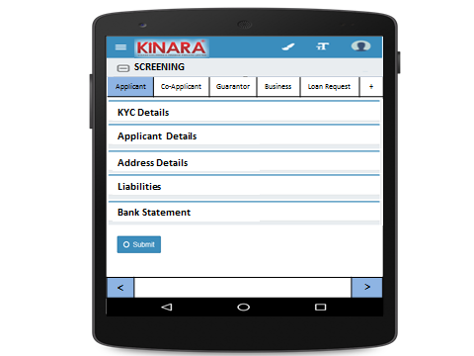

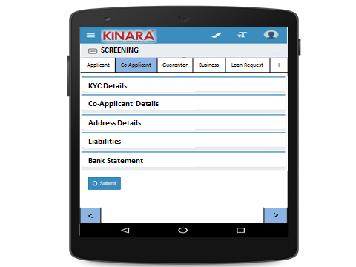

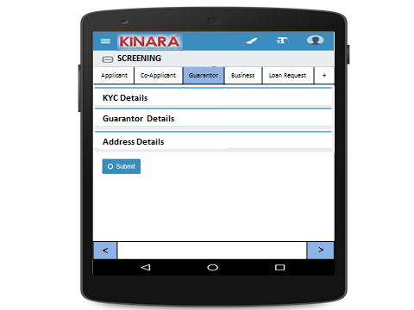

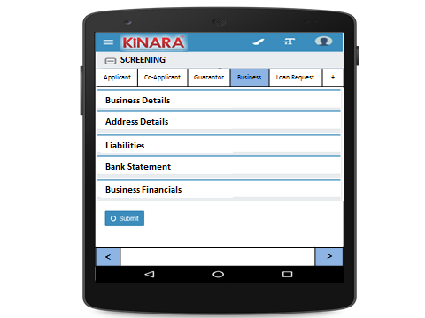

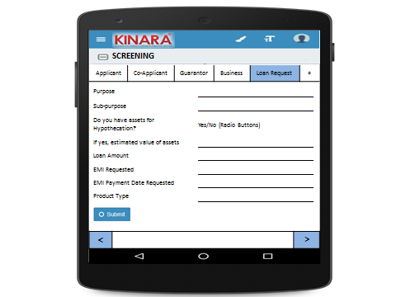

To add Co-Applicant or guarantor or remarks, click on + button.

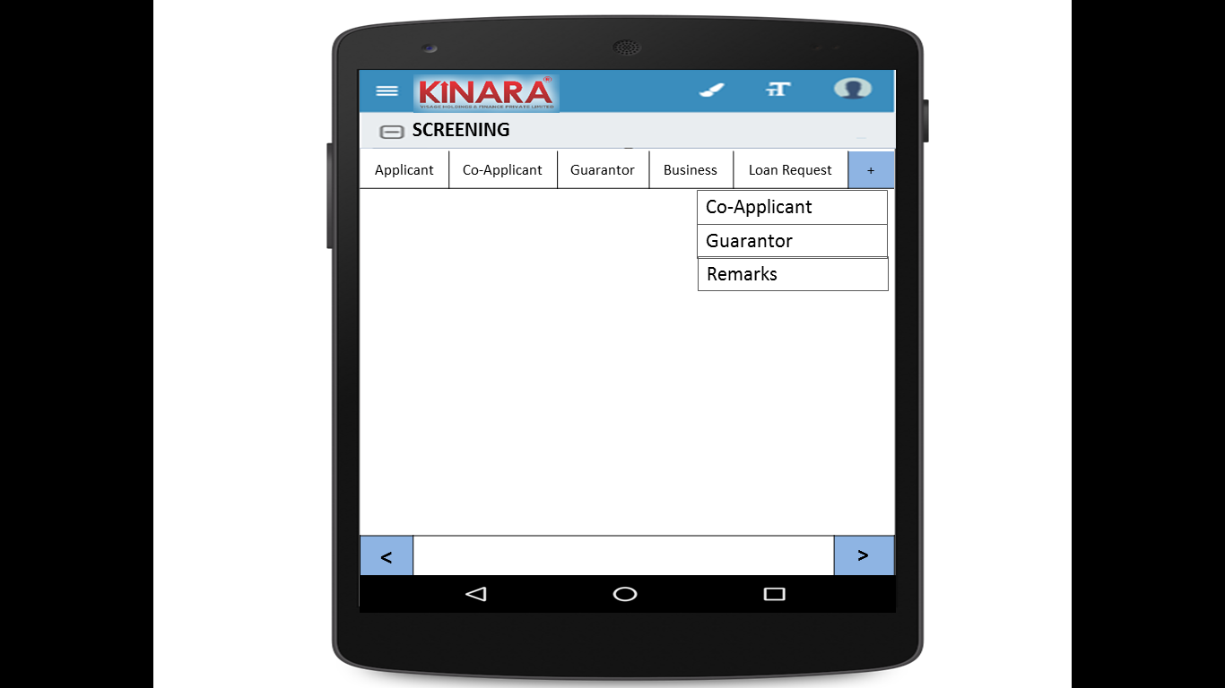

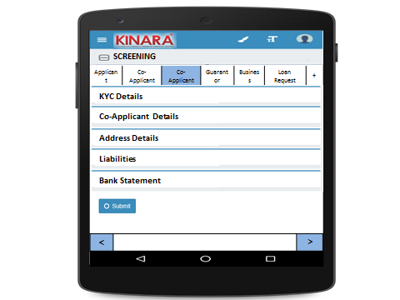

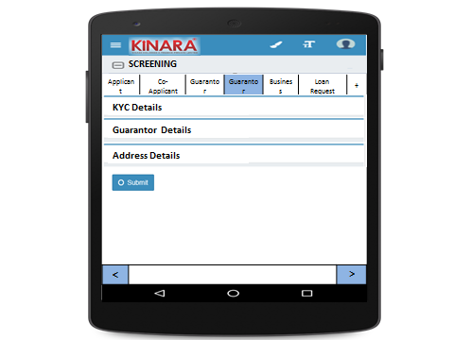

**Applicant**

Entity wise data capture and it will start with Applicant.



1. KYC Details:

Page 1

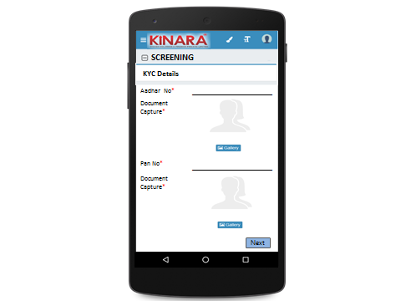

Page 2

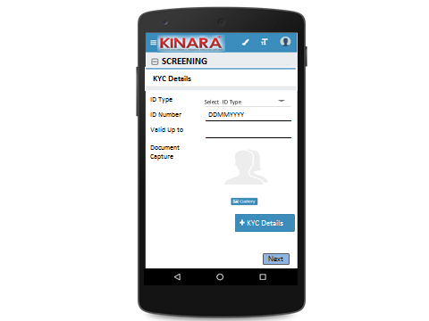

To add more than one KYC Details, Click on +KYC Details Button.

1. Applicant Details

Page 1

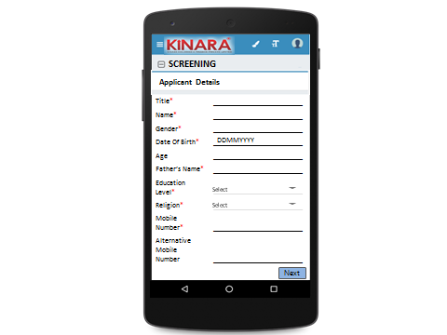

Page 2

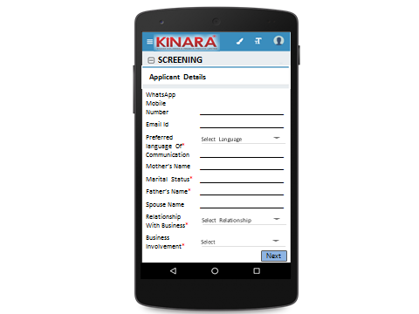

Page 3

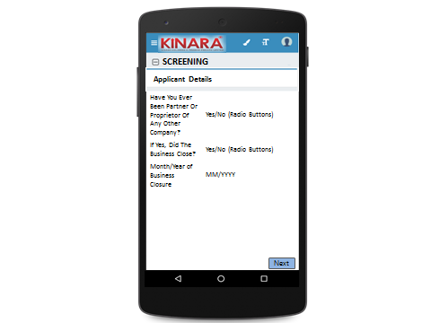

1. Address Details

Page 1

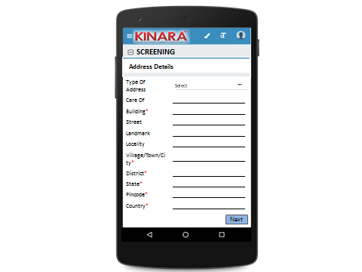

Page 2

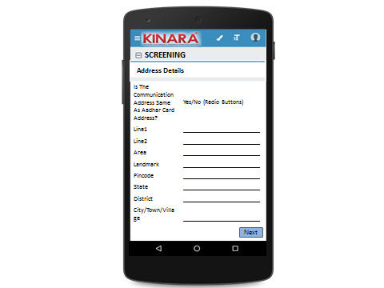

Page 3

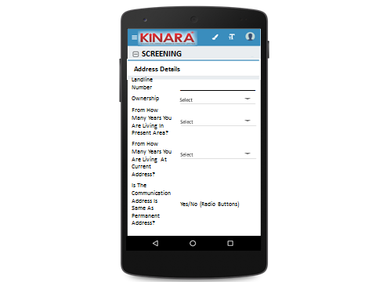

1. Liabilities

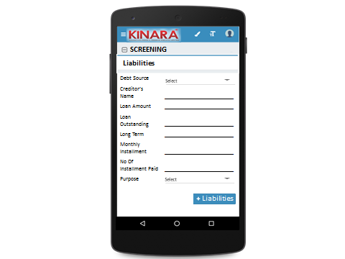

1. Bank Statement

Page 1

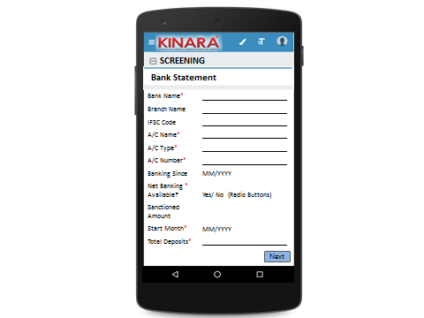

Page 2

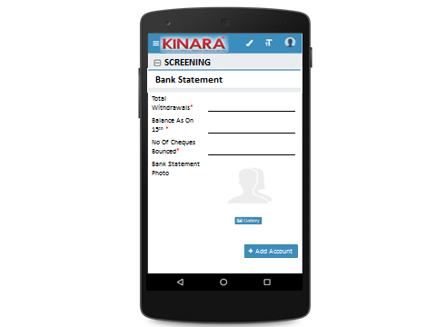

To add more than one account, click on +Add Account Button.

**Co-Applicant**

1. KYC Details

Page 1



Page 2

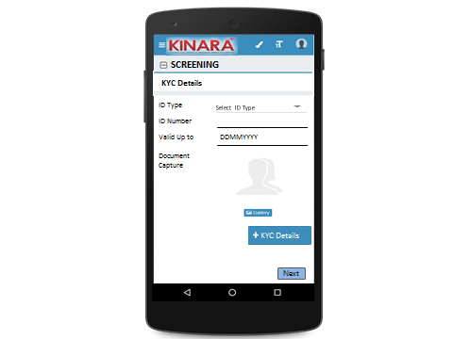

1. Co-Applicant Details

Page 1

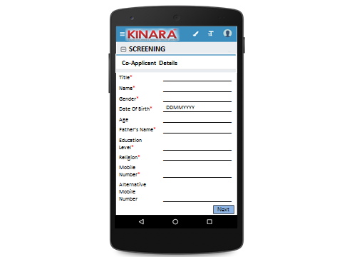

Page 2

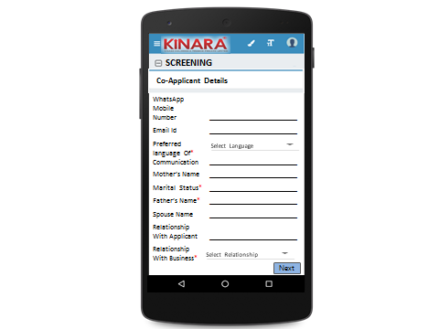

Page 3

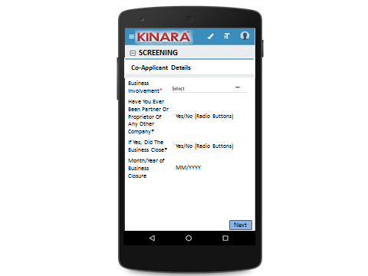

1. Address details

Page 1

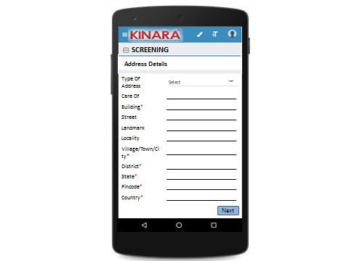

Page 2



Page 3

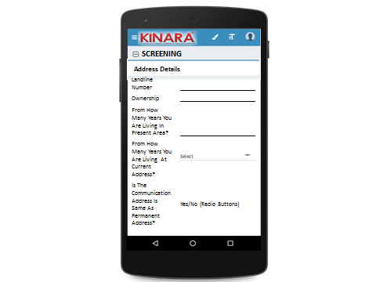

1. Liabilities



1. Bank Statement

Page 1

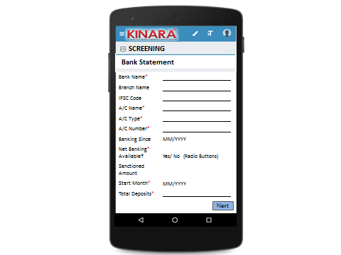

Page 2

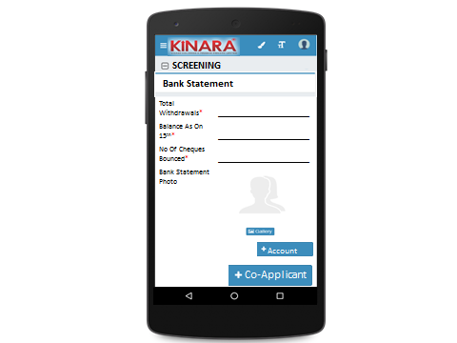

Please ignore +Co-Applicant Button. It has been explained in UI layout, how to add Co-Applicant.

**Guarantor**

1. KYC Details

Page 1



Page 2



1. Guarantor Details

Page 1

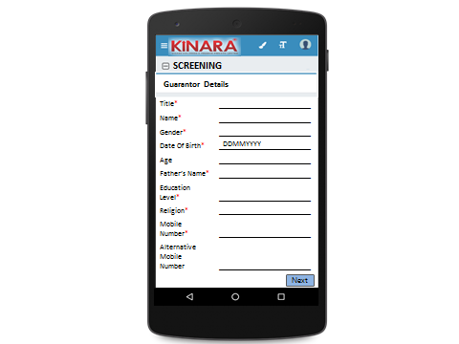

Page 2

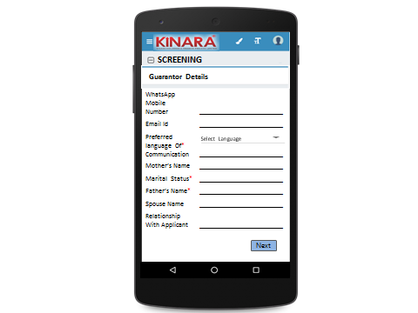

Page 3

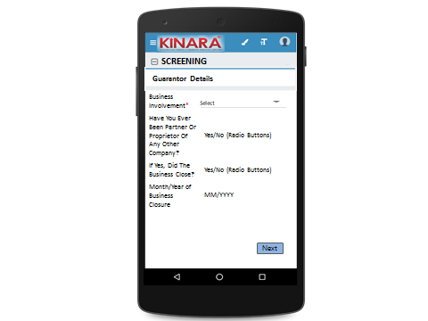

1. Address Details

Page 1



Page 2



Page 3



**Business**

1. Business Details

Page 1

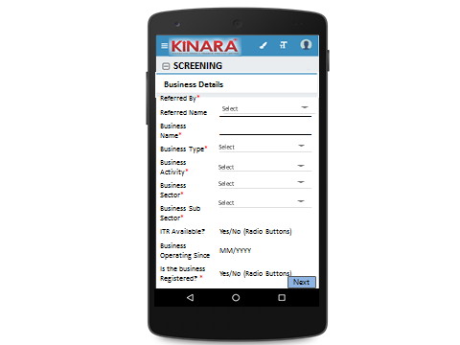

Page 2

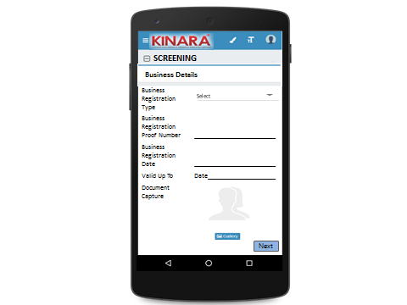

Page 3

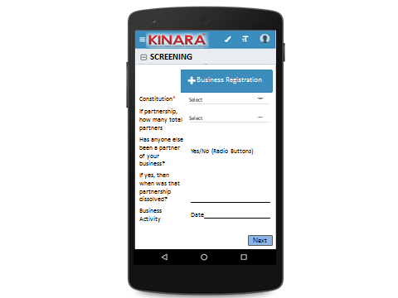

1. Address Details

Page 1

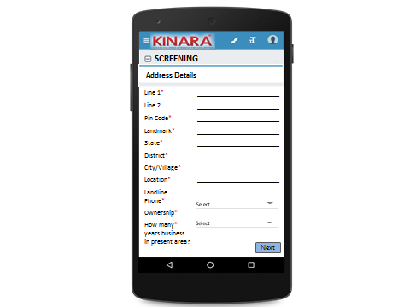

Page 2

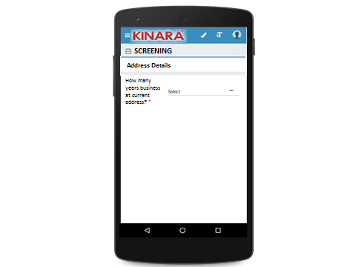

1. Liabilities



1. Bank Statement

Page 1



Page 2

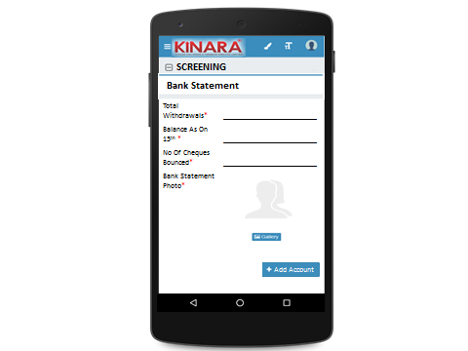

1. Business Financials

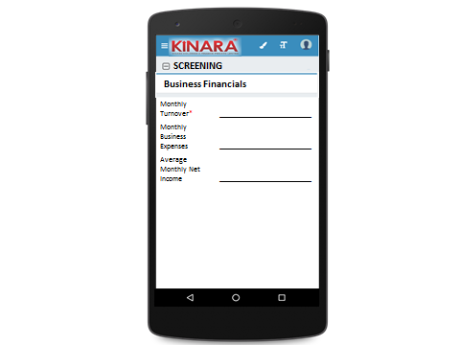

**Loan Request**

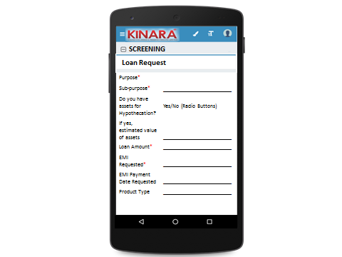

## Functional requirements

## 

* 1. Once the profile is selected from the screening queue, the loan officer captures the screening data and submits the profile to undergo an auto approval process.
  2. Here, de- dupe check and credit bureau check is conducted
  3. Risk Score- 1 (Screening Score) is also generated and screening score check is done (all checks run at back end).
  4. If approved, the profile goes to Application stage else it goes for Screening Review with the deviations that have been observed.

## Uploads

-NA-

## Downloads

-NA-

## Reports

Customer wise Risk Score

Lead Management Funnel - No. of leads generated, no. approved, no. rejected, no. follow- up and no. disbursed

# Screening Score

## UI specification

## Screenshot

NA

## Functional requirements

This is completely automated score calculation.

**Table 1**

|  |  |  |  |  |  |
| --- | --- | --- | --- | --- | --- |
| PARAMETER | A | B | C | D | E |
| Age | <25 | 25-30 | 30-40 | 40-50 | >50 |
| Married Status | Unmarried | Married | Separated | Divorced | Widow(er) |
| Housing Status | Owned | Own house without registration | Family property | Leased | Rental |
| Business Location Status | Owned | Own house without registration | Family property | Leased | Rental |
| # of Years residence in area /Locality | 1-2 | 2-3 | 3-4 | 4-5 | >5 |
| # of Years business in area /Locality | <6 months | 6 mos - 1 yr | 1-2 yr | 2-3 yr | >3 yrs |
| Business Vintage (verifiable) | <6 months | 6 mos - 1 yr | 1-2 yr | 2-3 yr | >3 yrs |
| Involvement in Biz | Full Time | Part Time | Not Involved | 0 | 0 |
| Business History | Clean - Single owner/  structure | Partnership with 2 partners | Partnership with more than 2 partners | Previously closed another business | Previously dissolved partnership |
| CB Deviation | No hit / -1-5 | 700+ | 600-700 | 550-600 | Less than 550 |
| Commercial CIBIL | No data | Standard | SUB/DBT/LSS | 0 | 0 |
| # of EMI cheque bounces | 0-1 | 2-3 | 3-4 | 4-6 | >6 |
| Quality of Loan Officer | New | Low Performer | Average Performer | High Performer | 0 |
| Quality of Hub | New | Low Performer - Low Sales/Poor Collections | Average Performer - Average Sales/Poor Collections | High Performer - Good Sales; Good Collections | Great Performer - Average Sales/Excellent Collections |
| Distance from the Hub | In the spoke | Just outside the Spoke | 5 kms from the closest spoke | 10 kms from the closest spoke | >10 kms from the closest spoke |

**Table 2**

|  |  |  |  |  |  |
| --- | --- | --- | --- | --- | --- |
| Parameters |  |  |  |  |  |
| Age | <25 | 25-30 | 30-40 | 40-50 | >50 |
| Married Status | Unmarried | Married | Separated | Divorced | Widow(er) |
| Housing Status | Owned | Own house without registration | Family property | Leased | Rental |
| Business premises Status | Owned | Own house without registration | Family property | Leased | Rental |
| # of Years residence in area /Locality | 1-2 | 2-3 | 3-4 | 4-5 | >5 |
| # of Years business in area /Locality | <6 months | 6 mos - 1 yr | 1-2 yr | 2-3 yr | >3 yrs |
| Business Vintage (verifiable) | <6 months | 6 mos - 1 yr | 1-2 yr | 2-3 yr | >3 yrs |
| Involvement in Biz | Full Time | Part Time | Not Involved |  |  |
| Business History | Clean - Single owner/  structure | Partnership with 2 partners | Partnership with more than 2 partners | Previously closed another business | Previously dissolved partnership |
| CB Score | No hit / -1-5 | 700+ | 600-700 | 550-600 | Less than 550 |
| Commercial CIBIL | No data | Standard | SUB/DBT/LSS |  |  |
| # of cheque bounces | 0-1 | 2-3 | 3-4 | 4-6 | >6 |
| Quality of Loan Officer | New | Low Performer | Average Performer | High Performer |  |
| Quality of Hub | New | Low Performer - Low Sales/Poor Collections | Average Performer - Average Sales/Poor Collections | High Performer - Good Sales; Good Collections | Great Performer - Average Sales/Excellent Collections |
| Distance from the Hub | In the spoke | Just outside the Spoke | 5 kms from the closest spoke | 10 kms from the closest spoke | >10 kms from the closest spoke |

**Table 3**

|  |  |  |  |  |  |
| --- | --- | --- | --- | --- | --- |
|  | A | B | C | D | E |
| Age | 1 | 3 | 5 | 5 | 2 |
| Married Status | 4 | 5 | 0 | 1 | 2 |
| Housing Status | 5 | 4 | 3 | 2 | 2 |
| Business Location Status | 5 | 4 | 3 | 2 | 1 |
| # of Years residence in area /Locality | 1 | 2 | 3 | 4 | 5 |
| # of Years business in area /Locality | 0 | 1 | 2 | 3 | 5 |
| Business Vintage (verifiable) | 1 | 2 | 3 | 4 | 5 |
| Involvement in Biz | 5 | 3 | 0 |  |  |
| Business History | 5 | 4 | 3 | 1 | 2 |
| CB Deviation | 3 | 5 | 4 | 2 | 0 |
| Commercial CIBIL | 4 | 5 | 0 |  |  |
| # of EMI cheque bounces | 5 | 3 | 2 | 1 | 0 |
| Quality of Loan Officer | 2 | 1 | 3 | 5 |  |
| Quality of Hub | 2 | 1 | 2 | 4 | 5 |
| Distance from the Hub | 5 | 4 | 2 | 1 | 0 |

**Table 4**

|  |  |  |  |
| --- | --- | --- | --- |
| Selection | Value | WEIGHT | Score |
| A | 0.2 | 5% | 1% |
| A | 0.8 | 5% | 4% |
| E | 0.4 | 5% | 2% |
| E | 0.2 | 5% | 1% |
| B | 0.4 | 7% | 3% |
| C | 0.4 | 8% | 3% |
| B | 0.4 | 10% | 4% |
| A | 1 | 5% | 5% |
| A | 1 | 5% | 5% |
| #N/A | #N/A | 15% | #N/A |
| #N/A | #N/A | 4% | #N/A |
| B | 0.6 | 12% | 7% |
| D | 1 | 4% | 4% |
| C | 0.4 | 5% | 2% |
| A | 1 | 5% | 5% |



* The four tables will determine the screening score.
* Each parameter has maximum five options and accordingly marks been mapped to each option.
* Maximum mark being 5 if any option fetches marks 5 then Value (in Table 4) will be 1. If 4 is scored out of 5 then value will be 0.8
* For all parameters weight is fixed (Table 4)
* Multiplying value and weight will give you Individual parameter score
* Add up all these parameter score to get final score.

## Upload

-NA-

## Download

-NA-

## Reports

-NA-